Two year old available for syndication on behalf of a Client
Bay Filly Zamindar ex Whitgift Rose

 |  |  | Mr Prospector | Raise a Native
Bay Filly - 11th April 2009 |  | Gone West | Mr Prospector | Gold Digger
 |  | Gone West | Secrettame | Secretariat
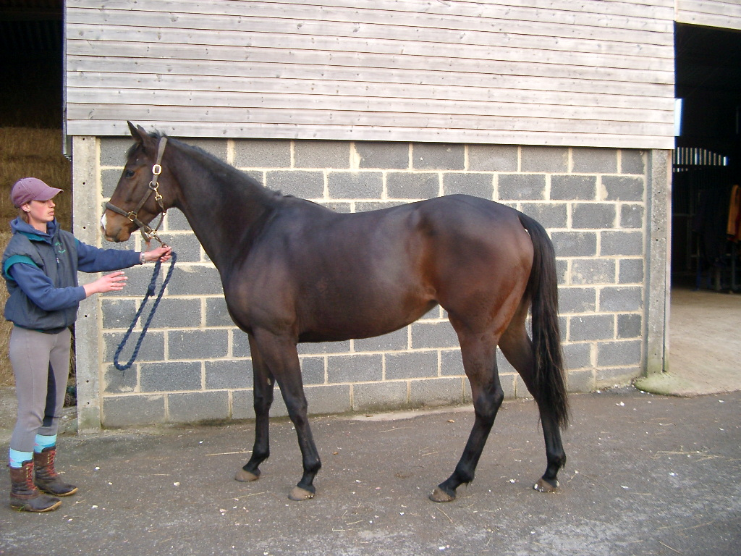 | Zamindar |  | Secrettame | Tamerett
 | Zamindar |  | The Minstrel | Northern Dancer
 |  | Zaizafon | The Minstrel | Fleur
 |  | Zaizafon | Mofida | Right Tack
 |  |  | Mofida | Wold Lass
 |  |  | Nureyev | Northern Dancer
 |  | Polar Falcon | Nureyev | Special
 |  | Polar Falcon | Marie d’Argonne | Jefferson 1
 | Whitgift Rose |  | Marie d’Argonne | Mohair
 | Whitgift Rose |  | Midyan | Miswaki
 |  | Celtic Wing | Midyan | Country Dream
 |  | Celtic Wing | Celtic Ring | Welsh Pageant
 |  |  | Celtic Ring | Pencuik Jewel

The above filly is very well grown with plenty of substance and scope. She is athletic and moves well. She has quite a lot of attitude which, providing, it is channelled in the right direction, should make her very competitive on the racecourse. She grew too big to consider running at two but will make an early to mid- season three-year old. She was backed during the summer at Mildmay and has been with Andrew Balding for the last couple of months and was shaping up nicely. She has now come back to Mildmay for a winter break and will return to Andrew in January.

Her dam, Whitgift Rose only ran four times over 8 &10 furlongs and was placed before being injured. Whitgift Rose is the dam of two winners one is still in training. She is by Polar Falcon, by Nureyev out of a mare from the family of Mr Prospector. Her 2nd dam was the dam of Celtic Swing champion two year old in Europe in 1994, a Group 1 sire both in UK and France

Zamindar was best over 6 furlongs. He won a Group3 and was placed in a Group 1 in France as a two year old and was also placed in Group company at three. He is the sire of 473 races value £9.4 million. His best progeny are Zarkava,, winner of four Group 1 races including the Prix de L’arc de Triomphe, Darjina winner of three Group I races, Zenda winner of the Group 1 Poule D’Essai des Pouliches, Coquerelle winner of the Group 1 Prix Saint-Alaryand and Timepiece winner of six group and Listed races including the Falmouth Stakes.

Zamindar is the sire of 5 Group 1 winners. All of his Group I winners are fillies. No doubt this is the reason why his yearling fillies have averaged over £62,000.compred with £19,000 for his yearling colts.

Stop Press: Zamindar fillies excel: Zaminast, a three year old filly won a Listed event at Leopardstown on October 30th and Zantenda won a Group 3 on the 8th September and was third in a Group 1 at Longchamps on October 2nd.

Cost of a 1/8th share. (Two 1/16h shares available)

This filly is available for lease for the 2012 flat season. The cost of a 1/8th share will be £3000.payable in two equal instalments of £1,500, the first on agreement to lease and the second on the 1st May 2012. At the end of the season (31st October 2012) the prize money will be distributed according to the percentage owned.

